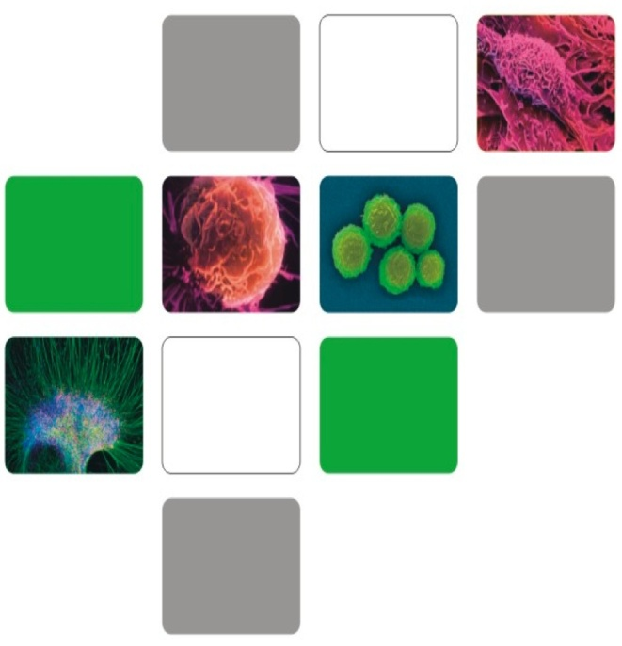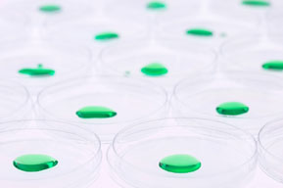

STEM CELL TREATMENT

**Diabetic Foot**

STEMCELL TREATMENT

carolptrsn@msn.com

www.stemcellsadvct.weebly.com

www.stemcellaware.com

Phone: 941-235-0088

Fax: 941-624-6133

DIABETIC OR ISCHEMIC FOOT

Diabetic or ischemic foot condition is the most common serious complication of diabetes. The nerve damage and impaired blood circulation in diabetes is a primary role in ulcer formation.

DETERMINE GOALS AND DEVELOP A PLAN WITH YOUR DOCTOR

Recently Diagnosed

* Treatment and Care
* Blood Glucose Control
* Medication and Conventional Treatment
* Complications

Safety

Options

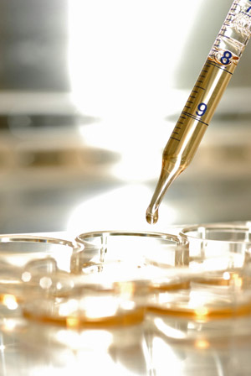

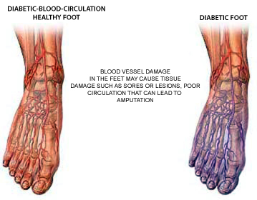

can be isolated and mobilized other stem cells to activate wound healing and new blood vessel formation resulting in earlier recovery of blood flow in the ischemic tissue.

BONE MARROW

Adult stem cells isolated from a patient’s own bone marrow can stimulate the development of new blood vessels, arterial repair and remodeling relieving the patient of rest pain and ischemic toe/foot ulcer.

UMBILICAL CORD

HLA matching umbilical cord blood-derived stem cells, cultured, expanded and prepared for treatment can also be locally injected to deliver the stem cells with comparative efficacy.

The unique healing actions of stem cells accelerate blood flow, restoration, and healing of injured ischemic tissues in addition to formation of new blood vessels. Other conventional treatment of diabetic foot ulcers involve intensive wound management, lengthy rehabilitation and is expensive.

Clinical symptoms after treatment include:

* Pain Relief (87%)
* Cold Feeling Decrease (91%)
* Walk Distance Increase (45%)
* Abscess Alleviated/Healed (92%)
* Gangrene Healed (20%)

PERIPERIAL BLOOD

From the patient’s own peripheral blood, specialized cells (endothelial progenitor cells)

STEM CELL USE FOR SOME ISCHEMIC FOOT ULCERS

DIABETES MELLITUS IS A COMMON CHRONIC DISEASE WITH SIGNIFICANT MORBIDITY, MORTALITY AND WORLDWIDE PREVALENCE. THE NUMBER OF PEOPLE WITH DIABETES IN THE MIDDLE EAST AND NORTH AFRICA IS EXPECTED TO RISE FROM 20.1 MILLION PEOPLE IN 2000 TO 52.8 MILLION IN 2030.

STEM CELLS

* Adult stem cells reside within tissues, blood, bone marrow, organs of the body.
* Adult stem cells are responsible for repair after injury.
* Adult stem cells help stimulate development of new blood vessels (angiogenesis.)
* Endothelial Progenitor Cells (EPCs) are a specialized adult stem cell involved in arterial repair s well as angiogenesis.
* Benefits from adult stem cell for ischemic ulcer and/or rest pain.
* Adult stem cells do not involve harvesting cells from embryo or an aborted fetus.

**GENERAL INFORMATION**

* **Type I results from the body’s failure to produce insulin and the person is required to inject insulin.**
* **Type II is most common, results from insulin resistance**

**Either the body does not produce enough insulin or the cells ignore the insulin. Insulin is necessary for the body to break down sugars and starches into glucose. Glucose is the basic fuel for cells in the body.**

* **When glucose builds up in the blood instead of going to the cells. It leads to diabetes**
* **Diabetes increases risk for other serious health problems.**
  + **Peripheral Artery Disease**
  + **Critical Leg Ischemia**