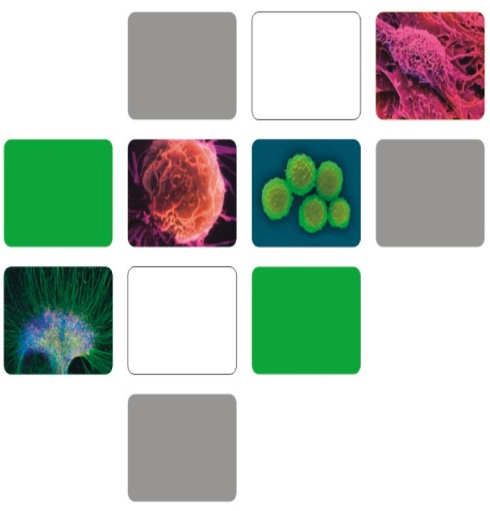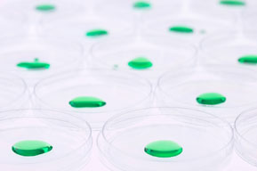

SUCCESSFULLY TREATED DISEASES

There are no other effective treatments for the diseases listed below, except umbilical cord stem cells.

GET MORE INFORMATION ONLINE

You can find information at:

www.stemcellsadvct.weebly.com

www.stemcellaware.com

I can help you if you need more information on stem cell awareness. If you have technical questions I can connect you with a medical expert.

Advocate contact information:

Carol Petersen

Phone: 941-235-0088

Fax: 941-624-6133

Email: carolptrsn@msn.com

1. ATAXIA

2. AUTISM

3. CEREBRAL PALSY

4. DIABETIC/ISCHEMIC FOOT

5. EPILEPSY

6. HEAD TRAUMA

7. MULTIPLE SCLEROSIS

8. MUSCULAR DYSTROPHY

9. OPTIC NERVE HYPOPLASIA (ONH)

10. SPINAL CORD INJURY

11. STROKE

STEM CELL **Information**

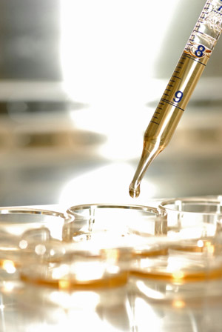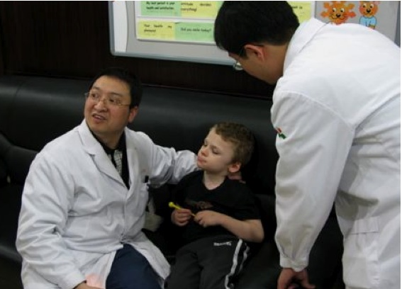

Stem cells normally are found in the blood, bone, marrow, skin, intestines, muscles, and other organs.

Umbilical cord stem cells are obtained from the umbilical cords of healthy newborn children, which is a rich source of stem cells.

Stem cells are parent cells for all tissues and organs.

These cells are basic building blocks of the human body.

The exist mainly for maintaining and repairing cells in the area where they are found.

They are able to repair, regenerate, rebulld, and rejuvenate other cells and tissues in the body.

Stem cells have unique properties:

1. Produce identical stem cells
2. Produce other cells and tissues (ie. Liver bone, skin, etc)

WHAT ARE STEM CELLS?

* 50% TO 70% OF PATIENTS TREATED WITH UMBILICAL CORD STEM CELLS HAVE SHOWN IMPROVEMENT.
* SIDE EFFECTS OCCUR IN LESS THAN 4% OF PATIENTS TREATED. SIDE EFFECTS ARE MINIMAL AND TREATABLE AND ARE MANIFESTED BY HEADACHES AND FEVERS.
* THERE ARE NO REJECTIONS.

THE PROCESS

1. The patient must fill out a standard initial medical evaluation form in order to evaluate the patient’s condition.
2. Once the form has been filled out, a Medical Committee in China will review the patients information and decide on whether the patient would profit from stem cell therapy.
3. The patient will be notified in 1 to 3 weeks on the status of acceptance.
4. Once accpeted the lpatient will choose a date that they would like to be treated and make reservations.

*NOTE: Acceptance is based on statistical data. The Medical Committee must feel that the patient will have a chance to improve 50% to 70% in order to be accepted for treatment.*

TREATMENT CENTERS

• QINGDAO, CHINA

• NANJING, CHINA

• BANGKOK, THAILAND

TREATMENT

1. One month stay in the hospital with a companion
2. The patient will receive 6 stem cell injections, 3 intravenously and 3 through lumbar puncture. Each injection contains 15 million stem cells.
3. The patient will receive daily acupuncture and physical therapy

ALTHOUGH STEM CELLS HAVE THE POTENTIAL TO REGENERATE ONE’S HEALTH AND IMPROVE WELLBEING, STEM CELLS ARE NOT A CURE.